CHELMARSH PARISH COUNCIL
Clerk: Mrs Freda Morris
18 Glebe Drive
Stottesdon
Kidderminster
DY14 8UF
Tele: 01746 718453
Email: chelmarshpc@btinternet.com

15th November 2015

To: All Parish Council members
The Public and press

A Parish Council meeting will be held on TUESDAY NOVEMBER 24th 2015 at 7.30pm in Chelmarsh Parish Hall for the transaction of business as set out in the agenda below which you are summoned to attend.

Yours sincerely
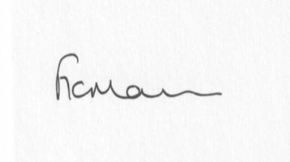
Mrs Freda Morris
Clerk

Agenda:
0. Parishioner’s time
1. Apologies for absence
2. Declaration of interests:
The Localism Act 2011, Relevant Authorities (Disclosable Pecuniary Interests) Regulations 2012.
Members are reminded that they are required to leave the room during the discussion and voting on matters in which they have a disclosable pecuniary interest, whether or not the interest is entered in the register of member’s interests maintained by the Monitoring Officer.
3. Minutes of last meeting held on 27th October 2015 (copy attached)
4. Matters arising from minutes:
a) Clerk’s update
b) Bench
c) Any other matters arising
5. Planning applications:
a) Reference: 15/04701/FUL (validated: 10/11/2015)
Address: Cleedsmore Farm, Astbury, Bridgnorth, Shropshire, WV16 6BW
Proposal: Erection of agricultural machinery store
Applicant: Mr C Winfield
b) Any received after issue of agenda
6. Planning permissions/refusals:
If any received after issue of agenda
7. Financial matters:
a) Accounts to be paid: Clerk’s fees/expenses, HMRC PAYE, S Grantham (bus shelter painting). Any others received after issue of the agenda
b) Bank statements
c) Bank mandate
8. Parish problems
9. Casual Vacancy
10. Reports (if available) from:
a) Parish Hall Committee – Use of field/car park/cricket field for fete 9th July 2016.
b) Neighbourhood Watch
c) Police
d) Unitary Cllr Tindall
11. Correspondence:
The Meadows update
SALC – Information Bulletins
SALC – Training sessions
Eardington PC – Astbury waterfall
Any other correspondence received after issue of agenda
12. Date next meeting – 26th January 2016

