CHELMARSH PARISH COUNCIL
Clerk: Mrs Freda Morris
18 Glebe Drive
Stottesdon
Kidderminster
DY14 8UF
Tele: 01746 718453
Email: chelmarshpc@btinternet.com
24th January 2017

To: All Parish Council members
The Public and press

A Parish Council meeting will be held on TUESDAY January 31st 2017 at 7.30pm in Chelmarsh Parish Hall for the transaction of business as set out in the agenda below which you are summoned to attend.

Yours sincerely
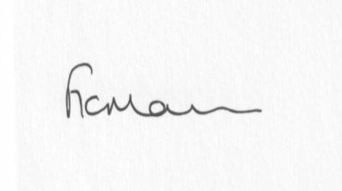
Mrs Freda Morris
Clerk

Agenda:
0. Parishioner’s time
1. Apologies for absence
2. Declaration of interests:
The Localism Act 2011, Relevant Authorities (Disclosable Pecuniary Interests) Regulations 2012.
Members are reminded that they are required to leave the room during the discussion and voting on matters in which they have a disclosable pecuniary interest, whether or not the interest is entered in the register of member’s interests maintained by the Monitoring Officer.
3. Minutes of last meeting held on 22nd November 2016 (copy attached)
4. Matters arising from minutes:
a) Clerk’s update
b) Meadow house update (if any)
5. Planning applications:
a) Reference: 16/05874/FUL
Proposal: Erection of an affordable three bedroom dwelling and parking, formation of vehicular access
Address: Proposed affordable dwelling south of Sutton Barn, Chelmarsh
Applicant: Thomas Hotchkiss
b) Any others received after issue of agenda
6. Planning permissions/refusals:
a) Any received after issue of agenda
7. Financial matters:
a) Accounts to be paid: Clerk’s fees (paid standing order) HMRC PAYE, Eon account, Npower account, RJM Contracts account. Parish Hall account. Any others received after issue of agenda
b) Bank statements/reconciliations
c) Precept
8. Parish problems
9. Reports (if available) from:
a) Parish Hall Committee
b) Neighbourhood Watch
c) Police
d) Unitary Cllr Tindall
10. Correspondence:
Letter from Parish Hall re: use of field for fete
Mr K Bradley – Local connection confirmation
SALC - Buckingham Palace Garden Party - 23rd May 2017
LJC/Drop in meting – Thursday 26th January – Severn Centre, Highley
SALC Area Committee meeting – Severn Centre – 24th January 2017
SALC – Information Bulletins
SALC – Training sessions
SC – Electoral Roll alterations
Any other correspondence received after issue of agenda
11. Date next meeting – 28th February 2017

