Chelmarsh Parish Council
Mrs Freda Morris – Locum Clerk
18 Glebe Drive,
Stottesdon,
Kidderminster,
DY14 8UF
01746 718453
fmorris30@btinternet.com

Date: 11th November 2014

To: All Parish Council members
The Public and press

A Parish Council meeting will be held on TUESDAY NOVEMBER 18TH 2014 at 7.30pm in Chelmarsh Parish Hall for the transaction of business as set out in the agenda below which you are summoned to attend.

Yours sincerely
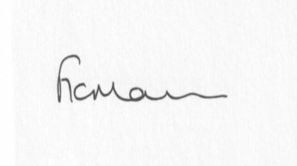

Mrs Freda Morris
Locum Clerk

AGENDA:

0. Parishioner’s time
1. Apologies for absence
2. Declaration of interests:
The Localism Act 2011, Relevant Authorities (Disclosable Pecuniary Interests) Regulations 2012.
Members are reminded that they are required to leave the room during the discussion and voting on matters in which they have a disclosable pecuniary interest, whether or not the interest is entered in the register of member’s interests maintained by the Monitoring Officer.
3. Minutes of last meeting – 23rd October 2014 and extra ordinary meeting dated 7th October 2014 (Copies attached)
4. Matters arising from minutes:
a) Incmoor trees
b) Flytipping
c) Memorial bench prices
d) Any other matters arising
5. Planning applications:
a) Erection of porch and single storey extension linking to existing annex – Ashwick House, Chelmarsh. Application number: 14/04456/FUL

b) Meadow House – Certificate of Lawfulness – Application number: 14/04696/CPL – For ‘Information only’.
c) Any others received after issue of the agenda
6. Planning permissions/refusals
7. Financial matters:
Accounts to be paid: BT telephone account - £16.74 (final invoice),
Npower - £82.74 (September) and ££83.68 (October)
SALC - cheque
Bank mandate
Any others received after issue of agenda
8. Correspondence
9. Parish problems:
a) potholes
10. Reports (if available) from:
Parish Hall Committee
Neighbourhood Watch
Police
Unitary Cllr Tindall
11. Report from LJC meeting 11th November 2014
12. Documents storage
13. Dates of future meetings
14. Appointment of Parish Council Clerk **

**Due to the confidential nature of the business to be discussed under item 14 the public and press shall be excluded under s1 (2) Public Bodies (Admission to Meetings) Act 1960 as amended

