CHELMARSH PARISH COUNCIL
Clerk: Mrs Freda Morris
18 Glebe Drive
Stottesdon
Kidderminster
DY14 8UF
Tele: 01746 718453
Email: chelmarshpc@btinternet.com

10th January 2015

To: All Parish Council members
The Public and press

A Parish Council meeting will be held on TUESDAY January 20th 2015 at 7.30pm in Chelmarsh Parish Hall for the transaction of business as set out in the agenda below which you are summoned to attend.

Yours sincerely
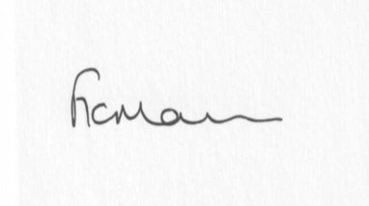
Mrs Freda Morris
Clerk

AGENDA:

0. Parishioner’s time
1. Apologies for absence
2. Declaration of interests:
The Localism Act 2011, Relevant Authorities (Disclosable Pecuniary Interests) Regulations 2012.
Members are reminded that they are required to leave the room during the discussion and voting on matters in which they have a disclosable pecuniary interest, whether or not the interest is entered in the register of member’s interests maintained by the Monitoring Officer.
3. Minutes of last meeting held on 18th November 2014 (copy attached)
4. Matters arising from minutes:
a) Clerk’s update
b) Any other matters arising
5. Planning applications:
a) If any received after issue of the agenda
b) Town and Country Planning Act 1990 - Information Only:
Planning reference: 14/05620/AGR
Development Proposed: Erection of steel portal framed building for the storage of machinery,
fodder and straw
Location: Land to the east of Covert Lane, Chelmarsh, Bridgnorth
OS Reference: 372323 286079
Applicant: Mr David Derricutt
6. Planning permissions/refusals:
a) Reference: 14/04456/FUL (validated: 09/10/2014)
Address: Ashwick House, Chelmarsh, Bridgnorth, WV16 6BA
Proposal: Erection of porch and single storey extension linking to existing annex
Decision: Grant Permission
b) Any others received after issue of the agenda
7. Financial matters:
a) Accounts to be paid: Any received after issue of the agenda
b) Bank/financial statement update/PAYE
c) Precept
d) Clerk’s contract of employment/job description
8. Correspondence:
SLC Bulletins
Buckingham Palace Garden Party nomination
Pensions Regulator
Council Tax Support Grant
Electoral Roll
Change of position of storage unit at Playing field
Any others received after issue of the agenda
9. Parish problems:
10. Reports (if available) from:
a) Parish Hall Committee
b) Neighbourhood Watch
c) Police
d) Unitary Cllr Tindall
11. Report from LJC meeting
12. Documents storage – update on filing cabinets
13. Date next meeting - 17th February 2015

