CHELMARSH PARISH COUNCIL
Clerk: Mrs Freda Morris
18 Glebe Drive
Stottesdon
Kidderminster
DY14 8UF
Tele: 01746 718453
Email: chelmarshpc@btinternet.com

19th October 2015

To: All Parish Council members
The Public and press

A Parish Council meeting will be held on TUESDAY OCTOBER 27th 2015 at 7.30pm in Chelmarsh Parish Hall for the transaction of business as set out in the agenda below which you are summoned to attend.

Yours sincerely
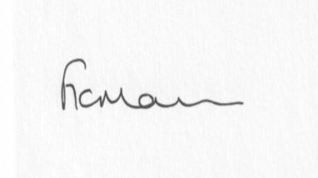
Mrs Freda Morris
Clerk

Agenda:
0. Parishioner’s time
1. Apologies for absence
2. Declaration of interests:
The Localism Act 2011, Relevant Authorities (Disclosable Pecuniary Interests) Regulations 2012.
Members are reminded that they are required to leave the room during the discussion and voting on matters in which they have a disclosable pecuniary interest, whether or not the interest is entered in the register of member’s interests maintained by the Monitoring Officer.
3. Minutes of last meeting held on 22nd September 2015 (copy attached)
4. Matters arising from minutes:
a) Clerk’s update
b) Bench in memory of Mrs Elizabeth Yeomans
c) Any other matters arising
5. Planning applications:
a) Reference: 15/04411/PFMPA (validated: 12/10/2015)
Address: Denn Farm, Occupation Lane, Chelmarsh, Bridgnorth, Shropshire, WV16 6BE
Proposal: Application for prior approval under Part 4, Class E of the Town & Country Planning (General Permitted Development) (England) Order 2015 for the temporary use of land for the purpose of commercial film making and the erection of associated temporary structures and associated works
Applicant: Mr R Davies
b) Any received after issue of agenda
6. Planning permissions/refusals:
If any received after issue of agenda
7. Financial matters:
a) Accounts to be paid: Clerk’s fees/expenses, HMRC PAYE, RJM Contracts account. Any others received after issue of the agenda
b) Bank statements
c) Quarterly bank reconciliation
d) Bank signatories
8. Parish problems
9. Casual Vacancy
10. Reports (if available) from:
a) Parish Hall Committee
b) Neighbourhood Watch
c) Police
d) Unitary Cllr Tindall
11. Correspondence:
Came and Co newsletter
Community Resilience
SALC AGM – 31ST October at Shirehall
SALC – Information Bulletins
SALC – Training sessions
LJC representative/information
Any other correspondence received after issue of agenda
12. Date next meeting – 24th November 2015

