CHELMARSH PARISH COUNCIL
Clerk: Mrs Freda Morris
18 Glebe Drive
Stottesdon
Kidderminster
DY14 8UF
Tele: 01746 718453
Email: chelmarshpc@btinternet.com

18th June 2016

To: All Parish Council members
The Public and press

A Parish Council meeting will be held on TUESDAY July 26th 2016 at 7.30pm in Chelmarsh Parish Hall for the transaction of business as set out in the agenda below which you are summoned to attend.

Yours sincerely
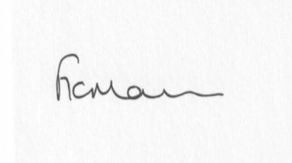
Mrs Freda Morris
Clerk

Agenda:
0. Parishioner’s time
1. Apologies for absence
2. Declaration of interests:
The Localism Act 2011, Relevant Authorities (Disclosable Pecuniary Interests) Regulations 2012.
Members are reminded that they are required to leave the room during the discussion and voting on matters in which they have a disclosable pecuniary interest, whether or not the interest is entered in the register of member’s interests maintained by the Monitoring Officer.
3. Minutes of last meeting held on 28th June 2016 (copy attached)
4. Matters arising from minutes:
a) Clerk’s update
b) Meadow house update
5. Planning applications:
a) If any received after issue of the agenda
6. Planning permissions/refusals:
a) Any received after issue of agenda
7. Financial matters:
a) Accounts to be paid: Clerk’s fees (July/August), HMRC PAYE, Eon account, Npower account,RJM Contracts account. Any others received after issue of agenda
b) Bank statements
c) VAT return confirmation
8. Parish problems
9. Reports (if available) from:
a) Parish Hall Committee
b) Neighbourhood Watch
c) Police
d) Unitary Cllr Tindall
10. Correspondence:
Resignation of Cllr Hornby/posters to be put up in parish
SALC – Information Bulletins
SALC – Training sessions:
Letter from Mr and Mrs Price re: use of cricket field for wedding
Donation request Search and Rescue
Any other correspondence received after issue of agenda
12. Date next meeting – 27th September 2016

