CHELMARSH PARISH COUNCIL
Clerk: Mrs Freda Morris
18 Glebe Drive
Stottesdon
Kidderminster
DY14 8UF
Tele: 01746 718453
Email: chelmarshpc@btinternet.com
2st February 2017

To: All Parish Council members
The Public and press

A Parish Council meeting will be held on TUESDAY February 28th 2017 at 7.30pm in Chelmarsh Parish Hall for the transaction of business as set out in the agenda below which you are summoned to attend.

Yours sincerely
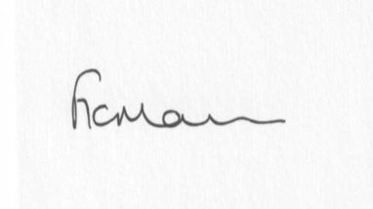
Mrs Freda Morris
Clerk

Agenda:
0. Parishioner’s time
1. Apologies for absence
2. Declaration of interests:
The Localism Act 2011, Relevant Authorities (Disclosable Pecuniary Interests) Regulations 2012.
Members are reminded that they are required to leave the room during the discussion and voting on matters in which they have a disclosable pecuniary interest, whether or not the interest is entered in the register of member’s interests maintained by the Monitoring Officer.
3. Minutes of last meeting held on 31st January 2017 (copy attached)
4. Matters arising from minutes:
a) Clerk’s update:
Reply from SC re: Mr and Mrs Kenneth Bradley - affordable housing application
Reply from SC re; parish problems
b) Meadow house update (if any)
5. Planning applications:
a) Any others received after issue of agenda
6. Planning permissions/refusals:
a) Any received after issue of agenda
7. Financial matters:
a) Accounts to be paid: Clerk’s fees (paid standing order) HMRC PAYE. Any others received after issue of agenda
b) Bank statements
c) Financial Regulations/Standing Orders update
8. Parish problems
9. Reports (if available) from:
a) Parish Hall Committee
b) Neighbourhood Watch
c) Police
d) Unitary Cllr Tindall
10. Correspondence:
Letter from Parish Hall re: Nomination of representative to Parish Hall Committee
SALC – Information Bulletins
SALC – Training sessions
SC – Electoral Roll alterations
Vicky Turner, SC - PTL18U83 PO Hampton Loade, Bridgnorth WV15 6HD iGIS coordinates 374567 286427
SC - Notice of confirmation of TCPA diversion: FP 14B Chelmarsh
Vicky Turner - Highley and Chelmarsh LJC notes from meeting
SALC - Media Release: Conference to focus on improving care for people living with dementia
SALC - Armed Forces Day preparation in Shropshire
SALC - Local Plan Review Consultation
Any other correspondence received after issue of agenda
11. Date next meeting – 27th March 2017

