CHELMARSH PARISH COUNCIL
Clerk: Mrs Freda Morris
18 Glebe Drive
Stottesdon
Kidderminster
DY14 8UF
Tele: 01746 718453
5th May 2017

To: All Parish Council members
The Public and press

The Annual Parish Council meeting will be held on TUESDAY May 16th 2017 at 7.30pm in Chelmarsh Parish Hall for the transaction of business as set out in the agenda below which you are summoned to attend. The Annual Parish meeting will follow this meeting.

PC Ann O’Leary has accepted the invitation to attend this meeting.

Yours sincerely
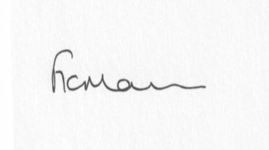 Please arrive early in order to sign your Declartation of Acceptance of Office
Prior to the meeting commencing.
Mrs Freda Morris
Clerk

Agenda:
1. Election of Officers:
Chairman
Vice Chairman
To elect any other committees/representatives as deemed necessary
2. Public participation (maximum 15 minutes) - the meeting will be suspended for this item.
3. Apologies for absence
4.. Declaration of interests:
The Localism Act 2011, Relevant Authorities (Disclosable Pecuniary Interests) Regulations 2012.
Members are reminded that they are required to leave the room during the discussion and voting on matters in which they have a disclosable pecuniary interest, whether or not the interest is entered in the register of member’s interests maintained by the Monitoring Officer.
5. Minutes of last meeting held on 25th April 2017
6. Matters arising from minutes:
a) Clerk’s update
b) Meadow house update (if any)
7. Planning applications:
a) Any others received after issue of agenda
8. Planning permissions/refusals:
a) Any received after issue of agenda
9. Financial matters:
a) Accounts to be paid: Clerk’s fees (paid standing order) HMRC PAYE, Came and Co Insurance renewal. Any others received after issue of agenda
b) Bank statement
c) Accounts/Audit
d) Income - Remittance Advice Notification (precept)
10. Parish problems
11. Reports (if available) from:
a) Parish Hall Committee
b) Neighbourhood Watch
c) Police
d) Unitary Cllr Tindall
12. Correspondence:
SALC – Information Bulletins
SC – Electoral Roll alterations
SC - 17/03098/NEWNUM Street Name
Any other correspondence received after issue of agenda
Ben Walker - Fibre Optic broadband in Chelmarsh reply
Response re: speeding issues in Chelmarsh
Response re: overflowing cesspit on BW
13. Date next meeting – 27th June 2017

