CHELMARSH PARISH COUNCIL
Clerk: Mrs Freda Morris
18 Glebe Drive
Stottesdon
Kidderminster
DY14 8UF
Tele: 01746 718453
Email: chelmarshpc@btinternet.com

15th April 2015 Please note change of time as this meeting is prior to the Annual Parish meeting at 7.45pm.

To: All Parish Council members
The Public and press

A Parish Council meeting will be held on TUESDAY APRIL 28th 2015 at 7.00pm in Chelmarsh Parish Hall for the transaction of business as set out in the agenda below which you are summoned to attend.

Yours sincerely
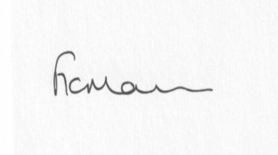
Mrs Freda Morris
Clerk

Agenda:
0. Parishioner’s time
1. Apologies for absence
2. Declaration of interests:
The Localism Act 2011, Relevant Authorities (Disclosable Pecuniary Interests) Regulations 2012.
Members are reminded that they are required to leave the room during the discussion and voting on matters in which they have a disclosable pecuniary interest, whether or not the interest is entered in the register of member’s interests maintained by the Monitoring Officer.
3. Minutes of last meeting held on 24th March 2015 (copy attached)
4. Matters arising from minutes:
a) Clerk’s update:
b) Any other matters arising
5. Planning applications:
a) If any received after issue of agenda
6. Planning permissions/refusals:
Reference: 15/01104/TCA (validated: 10/03/2015)
Address: Bridge House And School, Chelmarsh, Bridgnorth, Shropshire, WV16 6AX
Proposal: Various works to trees (see attached statement) within Chelmarsh Conservation Area
Decision: No Objection
7. Financial matters:
a) Accounts to be paid: Clerk’s fees, HMRC, SALC subs, Npower accounts, Insurance
b) To approve year end accounts
Any received after issue of the agenda
8. Correspondence:
Reply from MP re: Incmoor trees
Reply from resident re: Meadow House
SALC Bulletins
HMRC
9. Parish problems:
10. Reports (if available) from:
a) Parish Hall Committee
b) Neighbourhood Watch
c) Police
d) Unitary Cllr Tindall
11. Documents storage – update on filing cabinets
12. Date next meeting

