CHELMARSH PARISH COUNCIL
Clerk: Mrs Freda Morris
18 Glebe Drive
Stottesdon
Kidderminster
DY14 8UF
Tele: 01746 718453
Email: chelmarshpc@btinternet.com

17th May 2015

To: All Parish Council members
The Public and press

The Annual Parish Council meeting will be held on TUESDAY MAY 26th 2015 at 7.30pm in Chelmarsh Parish Hall for the transaction of business as set out in the agenda below which you are summoned to attend.

Yours sincerely
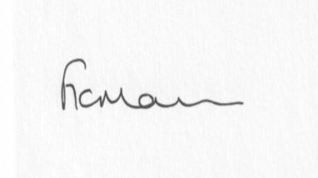
Mrs Freda Morris
Clerk

Agenda:
1. a) Election of Chairman
b) Signing of declaration of acceptance of office
c) Election of Vice-chairman
d) Signing of declaration of acceptance of office
e) Election of others officers to appropriate committees
2. Parishioner’s time: Standing Orders to be suspended for this item.
3. Apologies for absence
4. Declaration of interests:
The Localism Act 2011, Relevant Authorities (Disclosable Pecuniary Interests) Regulations 2012.
Members are reminded that they are required to leave the room during the discussion and voting on matters in which they have a disclosable pecuniary interest, whether or not the interest is entered in the register of member’s interests maintained by the Monitoring Officer.
5. Minutes of last meeting held on 28th April 2015 (copy attached)
6. Matters arising from minutes:
a) Clerk’s update:
b) Any other matters arising
7. Planning applications:
a) If any received after issue of agenda
8. Planning permissions/refusals:
9. Financial matters:
a) Accounts to be paid: Clerk’s fees, HMRC, Insurance. Donations to WI, Jubliee Club, Chelmarsh PCC.
Any others received after issue of the agenda.
b) To approve Internal Audit report/completion of Audit document
c) Bench in memory of Elizabeth Yeomans
10. Correspondence:
Reply from MP and Shropshire Council re: Meadow House
Reply from resident re: Meadow House
SALC Bulletins
Any other correspondence received
11. Parish problems:
12. Reports (if available) from:
a) Parish Hall Committee
b) Neighbourhood Watch
c) Police
d) Unitary Cllr Tindall
13. Documents storage – update on filing cabinets
14. Date next meeting – 23rd June 2015 and confirmation of future meetings

