**Stottesdon and Sidbury Parish Council**

The **Annual Parish Meeting** will be held at **Chorley Village Hall** on **Monday April 7th 2025 at 7.30pm**.

Local Government electors for the Parish will be entitled to vote at the meeting which will be open to the public (LGA 1972, ss13(1) and 32 (1)

*This is the meeting of the Parish, and all parishioners are welcome to attend and find out what is going on where you live and put new ideas forward for consideration.*

*.*

*Tea and coffee will be served.*

**Guest speaker will be:**

**PC 21624 Nicholas NOLAN**

**Safer Neighbourhood Officer | Cleobury & Highley SNT | West Mercia Police**

**Agenda:**

00. Chairman’s welcome and introduction of guest speaker:

01. Apologies

02. Minutes of last meeting – April 22nd, 2024

03. Matters arising from minutes:

04. Chairman’s Annual Report

05. Shropshire Councillor’s reports

06. Organisation reports:

a) Stottesdon School/Nursery

b) Chorley Village Hall/Show

c) WI

d) Stottesdon/Sidbury Church

e) Chorley Chapel

f) Lengthsman Scheme

07. Parish problems

08. Chairman’s closing comments

10. Date of next meeting – 28th April 2025 (Parish Council meeting)

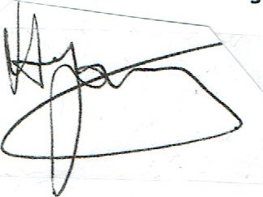

David Young - Chairman